**Car Chase Game Design**

**Abdiel Nie**

1. **Specification phase – answer questions**
2. This is a game which player control an aircraft in the universe. The more time you fly, the higher mark you will get. In this game, there are planets, missiles, blackholes and energy aircraft you need to stay away. In order to get higher mark.
3. **Design phase**
   1. **UML Class Design**

|  |  |  |  |
| --- | --- | --- | --- |
| Aircraft | Reference | Energy_Aircraft | Missile |
| Gravity value  X-axis value  Y-axis value  Speed (left right)  Acceleration (up)  Size (when in the air) | X-axis value  Y-axis value  Repeated time  MapSpeed | X-axis value  Y-axis value  Repeated time  TrapSettingTime | X-axis value  Y-axis value  Repeated time |
| SpeedUp ()  Gravity ()  GoLeft ()  GoRight()  Fly ()  Hit ()  Crash () | GoDown ()  Repeat () | Appear ()  Crash ()  Movement ()  SetTrap ()  Output() | Appear ()  Crash ()  Movement ()  Burning/Crash ()  Hit () |
| Obstacles | Trap | Background/System |  |
| X-axis value  Y-axis value  MapSpeed  Repeated time | MapSpeed | RandomIndex |  |
| GoDown ()  RandomType ()  Crash () |  | ObstacleTime ()  CarTime() |  |

* 1. **Flowchart / pseudocode**

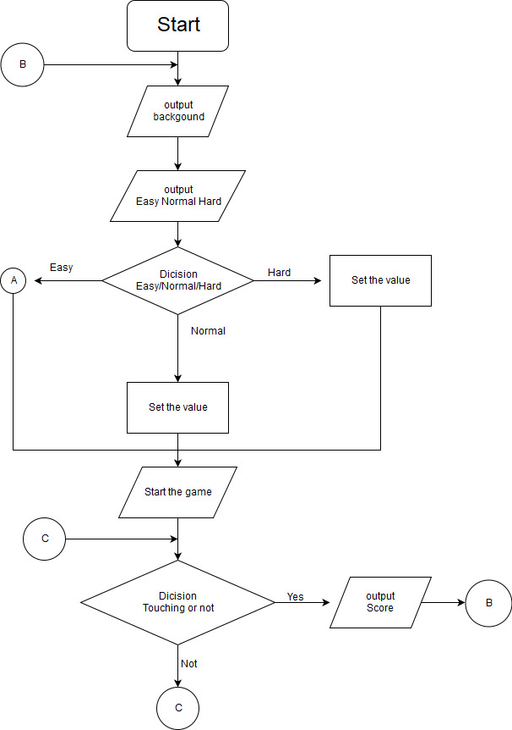

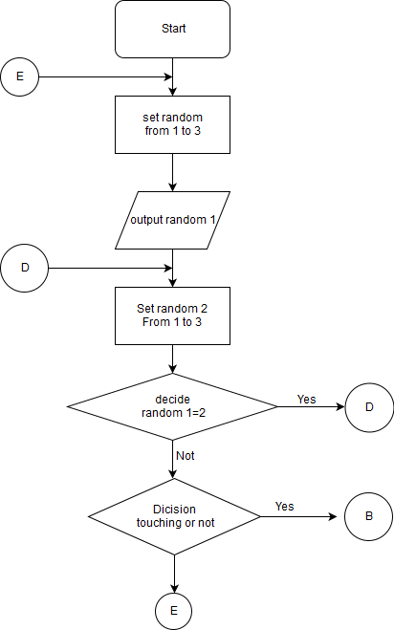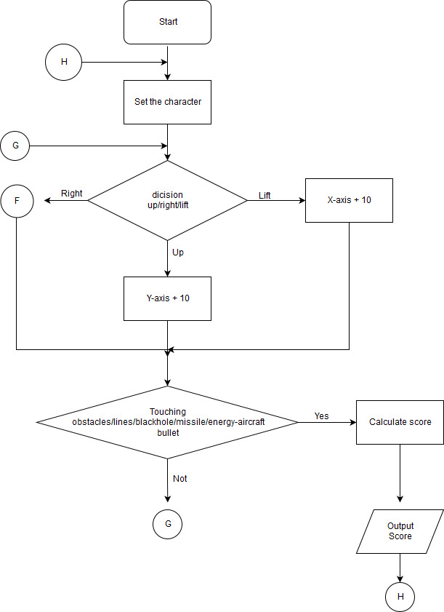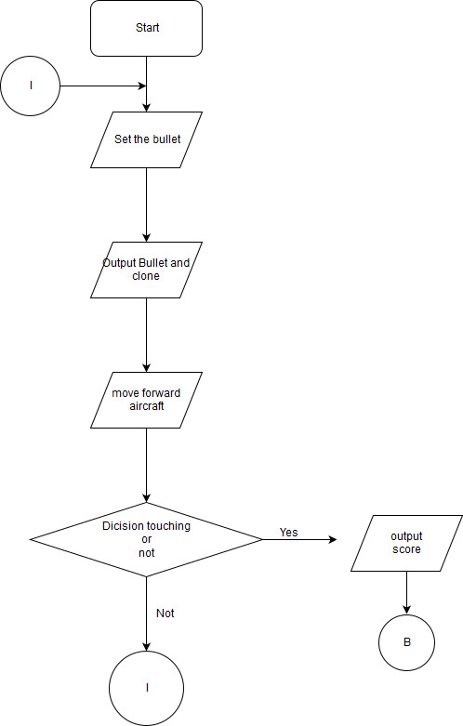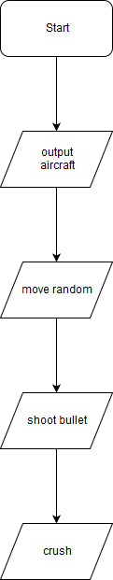

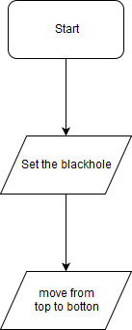

1. **Implementation phase**

Please look the real program

1. **Testing phase**
2. The real planet and cloned planet appears in the same position.

Debugging: The variables in the if statements of cloned planet is “random” which is used to determinate the position in real planet. Just changed variable “random” in to “random2”.

1. The reference (stars) will cover the planet or energy aircraft in the game.

Debugging: Set stars to the back layer when program starts.

1. The score stops increasing when it reaches to 599.

Debugging: The determination of score I write when time>60 and time <29, which this situation is invalid. So change it into “time >29 and time< 60” will make it correct.